Configuring Tailwind

In this lecture, we are going to explore the configuration settings.

Is the primary location for performing adjustments to tailwind.CSS.

Let's review the configuration settings together.

Open the **tailwind.config.js** file.

This file was generated with the **npx tailwind init** command.

It'll contain the minimum configuration settings for tailwind. The first option is called **content**.

Afterward, we have the **theme** option:

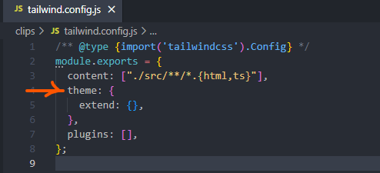

The **theme** option contains properties for modifying the colors, font sizes and other features of tailwind.

Lastly, we have the **plugins** option:

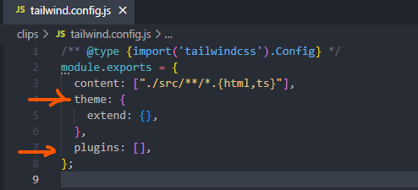

It's an array of plugins for extending tailwind.

if we leave these options empty, **tailwind** will use its default configuration, which is suitable for most projects.

In the resource section of this lecture, I provide a link to the configuration documentation page: <https://tailwindcss.com/docs/theme>

This page provides detailed information on configuring **tailwind**. On the sidebar, there's a page dedicated to each option.

This page gives us a general overview.

There is an alternative option for adding classes to tailwind.

Let's go back to our editor.

The default set of classes won't cover every scenario. We will need to add custom CSS classes to consider our template complete. Instead of adding them through the configuration option, we can add them directly in these **styles.css** file.

Let's try that out. In the template directory, open the **custom.css** file.

Copy everything inside this file.

Next, open these styles.css file and paste in the code:

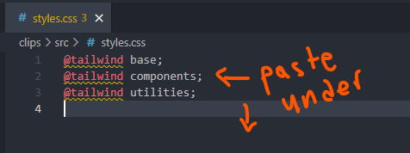

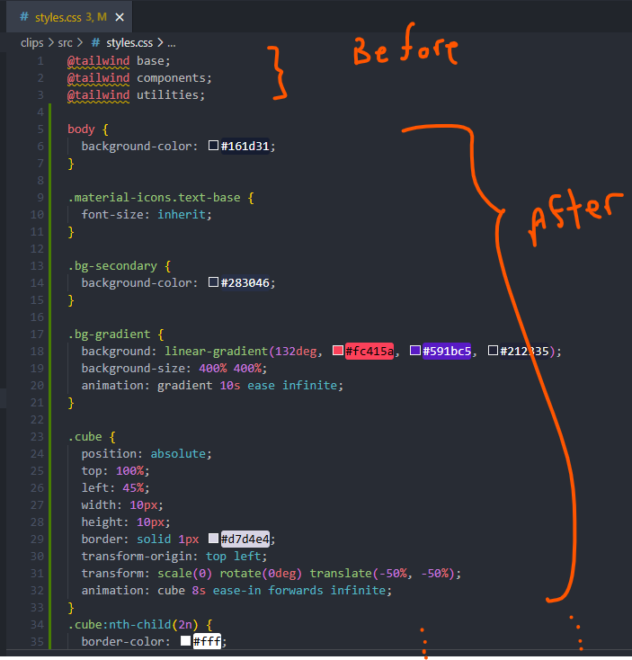

It's perfectly fine to add CSS to our style sheet. We don't need to locate every class inside the **tailwind.config.js** file, even though it's possible. Sometimes it is just easier to write regular CSS.

Let's refresh the page in the browser:



We're definitely getting closer. However, we need to make some final adjustments.

We will cover these adjustments in the next lecture.